AATC_Astar.py

Analysis
This module is used to manage the graph of the area the server manages and to perform the searches to find a short path around obstacles. The module has a number of different classes and functions including the DynoGraph object and the Astar2 and AstarPQ functions.
The program uses the A* algorithm to find a path between two points , it is a variant of the djsktra search using a heuristic to aid the search. A djsktra search expands the nodes which are closest to the start node in a wave like fashion, regardless of if the new nodes are closer to the target or further away. This results in a very large search space requiring large amounts of time and memory, making it not an option for this application. The A* search adds an additional heuristic to the search, the estimated number of steps to the target node, which is used to select the best next node. The algorithm will then prefer to expand nodes which are closer to the goal than ones which are further away. The heuristic governs the search of an A* algorithm , the more optimistic the algorithm so the short possible path it thinks is possible the longer the search will take if this path does not exist. Therefore to vastly improve the search speed one can modify the heuristic to be less optimistic i.e. not search for the optimal path but to search for a good path. This is one of the modifications I have made to the algorithm, the heuristic calculates the number of steps as the sum of the number of steps in each single dimension to the target h = abs (x1-x2)/xSize + abs (y1-y2)/ySize + abs (z1-z2)/zSize. This not only reduces the search space drastically but the operation to calculate the heuristic is much simpler than the admissable ( finds optimal path) h = sqrt(((x1/x2)/xSize)**2 + ((y1/y2)/ySize)**2+ ((y1/y2)/ySize)**2) completing an estimate in 1/3 to 1/5 of the time.
The search space which a conventional A* algorithm requires to find the optimal path across a uniform cost grid of width x and height y grows very quickly. As the algorithm must search every possible node to ensure it cannot find a shorter path, the length of each path is tied, so the number of nodes it must search increases with xy, in the case of this program where x and y could reach 400+ this is a very large number. In comparison the modified heuristic would break the ties by prefering a node which is closer to the target than a node which may provide no gains. The difference in the number of nodes searched is shown below. This estimate does not include a third dimension which would increase the difference further.

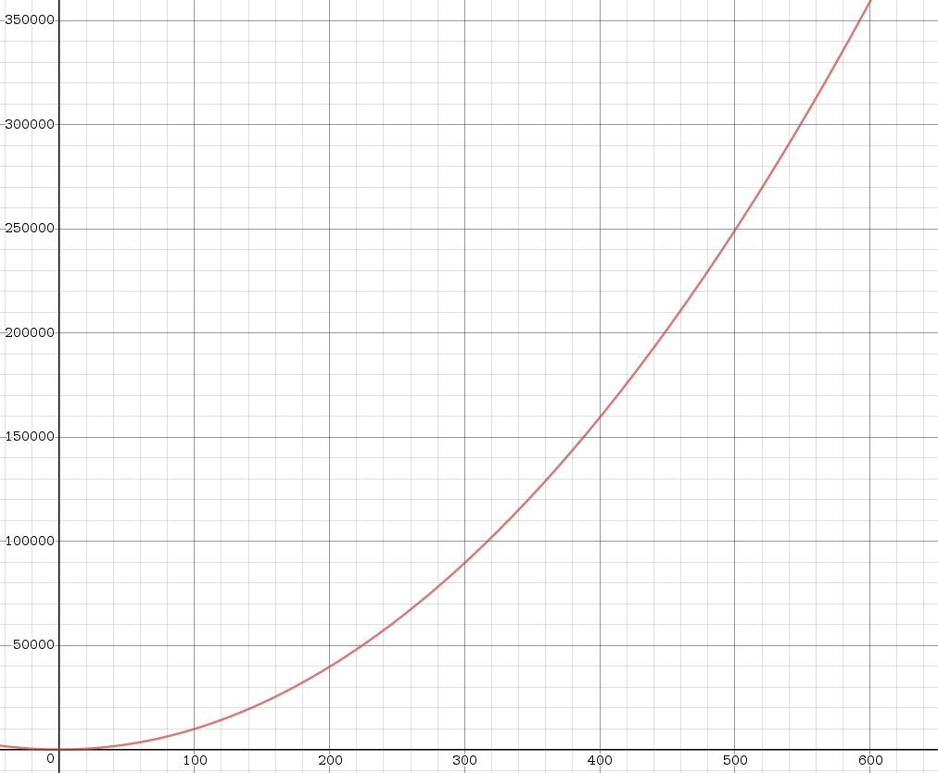
Desmos.com x^2- (x^2*2)^0.5

Another drawback of the A* algorithm is its response to encountering an obstacle , its heuristics lead it to believe that the best option is to expand the next set of nodes even if they are far away from the target. The modification instead allows the algorithm to proceed as far forward from the last node as possible in order to avoid greatly increasing the search space. In the example below the modified algorithm only requires 0.56 of the operations of the other while achieving a very similar path, for more complex paths the difference is greater ( 527 vs 143 if a second obstacle is added). The normal method to improve the search speed of an A* search in a mostly uniform grid and to counter ties is to use jump point search. However due to the nature of JPS to search until hitting an obstable the search would cover most of the graph before colliding with an obstacle, taking a large amount of time and requiring a large number of IO calls.

https://qiao.github.io/PathFinding.js/visual/

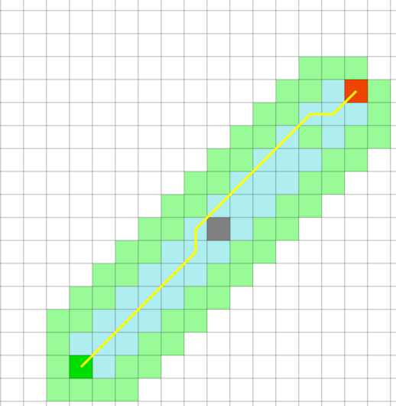
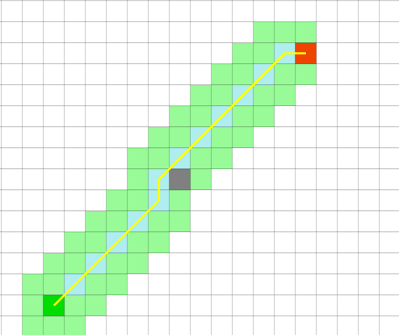

This application is aimed to support graphs of very large sizes, limited only by storage capacity and available memory space. In order to improve the size of graph which can be used in a search this module only loads the nodes required for the search into memory by splitting the nodes into blocks, the nodes requires are searched for and if a new block is required it is loaded. The graph object manages this automatically, using a hashing function ( in this case the integer division by the block size ) to determine the block ID. The block size is configurable, a greater block size could mean a greater memory usage , however the greater number of nodes in a block reduces the amount of IO requests which is benifitial for a a HDD with very low IOPS performance while a RAM drive , SSD or Optane cache could use smaller block sizes. Note that the opening of files includes some overhead via the unpickling of files , therefore it may be useful to increase the block size to improve performance at the cost of memory usage.

Import

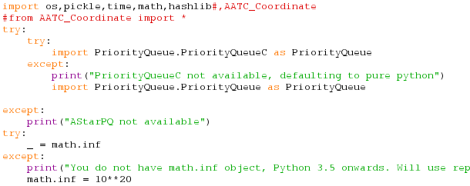
The module requires a number of other modules. Firstly the os module is required to automatically create the paths to files and folders in the graph folder directory. Pickle is required to read and write to these files. Time and math are required to time the operation and to provide functions and constants respectively. Hashlib is required for the hashing of the node cache.

The next set of imports attempt to import the priority queue module in C , if it fails in python, if that fails to alert the user that the import failed. The C version provides a large performance boost due to calling compiled C code created in cython.

The next statement is involved with the import statements, the maths module only contains the inf constant ( infinity) in versions 3.5 and above. This statement checks this is the case and if an error occurs sets the math.inf constant to 10^20. This technically creates a limit on the number of nodes which can be searched, however 10^20 is so large that such a number of nodes would require Zebibytes of storage capacity (log(128,10**20,1024) = 7.7).

Dynograph
This object stores and intefaces with the components of the graph used for the A* search. It manages storing the nodes , creating and storing the node_cache and managing the storage slots for each time frame.

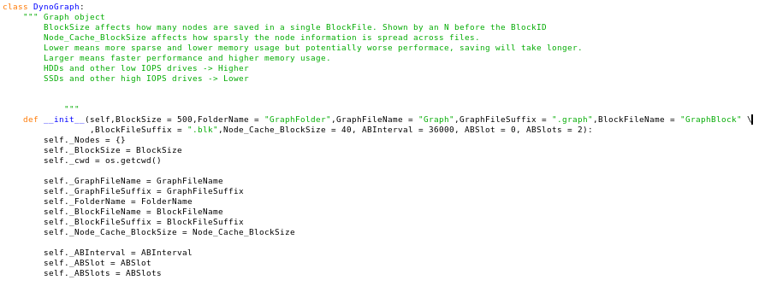
The dynograph object requires 0 arguments and 10 optional parameters. The block size controls how many nodes will be in a single block, the effects of which were descibed previously. The FolderName,GraphFileName,GraphFileSuffix, BlockFileName,BlockFileSuffix and Node_Cache_BlockSize control the naming schemes for the majority of the folders and files used by the dynograph system. The ABInterval , ABSlots and ABSlot control the AB saving system parameters. This system provides a way to control which set of folders the program will save in automatically such that different systems such as the A* search and no fly zone grapher are never accessing the same file which could lead to failures if they attempt to read and write without a lock.

This forms a file structure :
main_code_directory/GraphFolder/LETTER/
Where LETTER represents the current letter value. The the lowest folder contains all the blocks for that copy of the graph as well as the NodeCache files and the graph settings file.

This system allows the NoFlyZone grapher to write to one graph set and the A* search to read from the other. The time interval is the time in seconds for which the slot is valid, providing a buffer to prevent abuse of the NoFlyZone system as well as providing the no fly zone grapher time to write the correct values. The current slot is calculated using the formula ((time.time()+self.ABInterval*self.ABSlot)//self.ABInterval)%self.ABSlots. The time.time()+self.ABInterval*self.ABSlot calculates a time boundary in which the slot is using the offset by interval * slot. Integer division by the interval produces a pattern of a,b,c,d,....a,b,c,d... with increasing time slots. The modulus of this by the number of slots produces a value for each slot, from 0 → n where n is the number of slots -1. This added to 65 and converted to the ascii equivilant provides a letter for the folder name. This system ensures that each slot will be using a different folder at each time step of ABInterval.
In addition to setting up attributes from the arguments the attribute cwd is set to os.getcwd() to have a constant save directory for the program. Per default this is overridden each time the graph is loaded to ensure cross os compatibility (paths are different eg between linux and windows ).

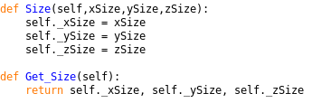
The Size method allows the size of each sector in the graph to be set, measured in longitude,latitude, meters. The get size method returns the size of the graph in a tuple of three items. The xSize,ySize and zSize variables are not initialised until Size or ImportGraph is called and will raise an error if used before this. This is left so that anyone using this program will know they have not correctly initialised the graph.

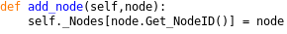
Add node simply adds a node to the nodes dictionary , identified by its nodeID.

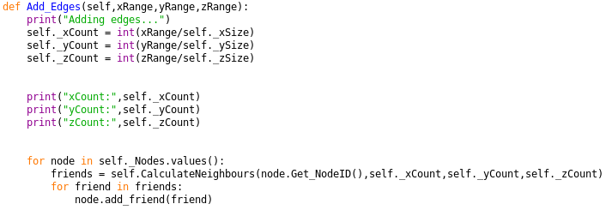
Add edges calculates the neighbours of each node using the Ranges in each dimensions as parameters and adds them to the relevant node. Count is the number of layer in that dimension e.g. a graph from x 0-> 1 with size 0.01 has a xCount of 100.

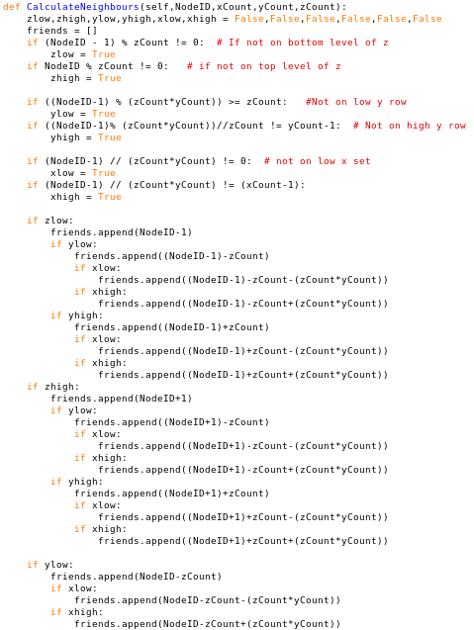
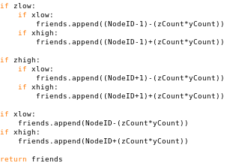
The calculate neighbours function is used to calculate the neighbours of every node in O(N) time, the best possible as N items must be accessed. The algorithm uses the known number of nodes in each dimension to calculate the NodeIDs of each neighbour instead of using the conventional 0(N^2) method of comparing every node to each other node which would be infeasable with large N. The program calculates 6 variables, two for each dimension which effectively store if the node is on the lowest or highest layer for that dimension. If not the variable is set to true. The combinations of each variable identify which neighbours of the node are valid. The program then calculates the nodeID by using the size of each layer. For this program to work the NodeIDs must be added in the order added to by Create_Graph, if any other order is used the program will fail. The description of how this algorithm functions is reasonably complex and therefore will not be described here, however it functions by assuming that the nodeIDs started at 1 and were added in increasing order in first z, then y then x, forming layers with patterns based off the size of each layers count value.

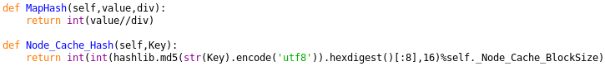
These hash functions are used to store and find the node cache files. The first is used to calculate a base value on the number of steps in a single dimension the point is from the origin, mapping it to the next lowest sector/node using the integer division of the value by the divisior.
The second value is designed to find a node_cache file based off it's nodeID. This uses the utf-8 string of the key as an input to the MD5 hashing function , obtains the first 8 bytes of the hash and converts it into an integer and finally mods this by the self.Node_Cache_BlockSize which is the number of different files used to store the node_cache. Compared to normal hashing functions which attempts to produce a one way function resistant to collisions this function attempts to evenly distribute the node_cache results over a number of files such that the number of node_cache components per file is of a reasonable value.

Node_Cache
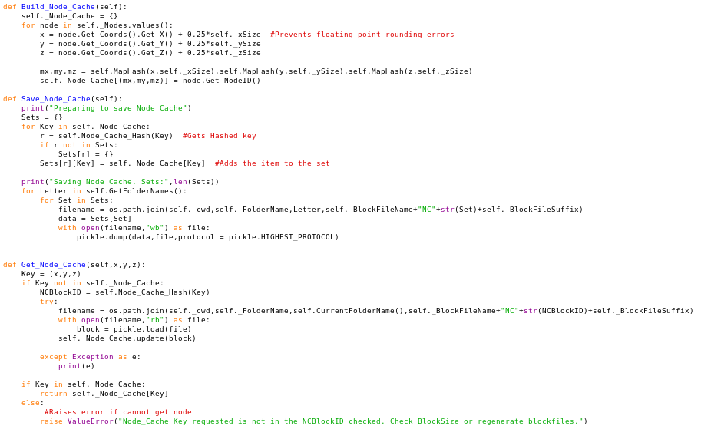
The build node_cache method sets up a simple way to quickly find the correct start or end nodeID from a pair of coordinates. The node_cache uses modulus to map each coordinate in a nodes sector to that nodeID by integer division by the size in that dimension. For each node the function offsets the coordinates slightly to prevent rounding errors in the division and obtains a key with which to store the nodeID for later referencing.

The Save_Node_Cache method is used to save the node_cache into multiple files to reduce the memory usage of a lookup and resulting search. Instead of loading all the dictionary into memory the system breaks up the dictionary into blocks which are saved seperatly based on the hash value of the key. The program places each key value pair into a set, initialising the dictionary if it does not exist. The program then saves the node_cache into the relevant folders each set as a single file using pickle.

The get_node_Cache function takes three parameters namely the x y and z coordinates for the nodeID which should be found. If the key is not already loaded the program calculates the ID of the block and opens the file, loading the dictionary into the Node_Cache dictionary. The program then attempts to find the node in the updated dictionary , if it is present it returns the NodeID if not an exception is raised.

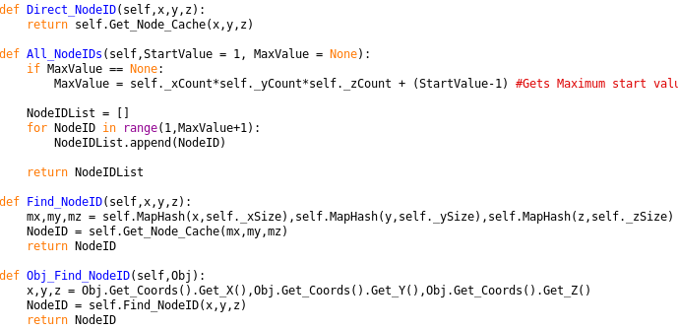

Direct_NodeID calls the Get_Node_Cache function directly without modding the key.
All_NodeIDs obtains a list of all nodeIDs using the two given parameters, if a max value is not given the program calculates the top value for the nodeIDs . Then loops through all values from 1 → MaxNodeID and returns the list.
Find_NodeID takes the x,y,z coordinates of a point and returns the correct result using the Get_Node_Cache function.
Obj_Find_NodeID wraps around Find_NodeID, taking an object with a coordinate attribute and obtains the x,y,z coordinates from this.

The save graph method takes two optional boolean parameters AutoNodeSave and AutoCacheSave which set if the Nodes or the NodeCache should be saved when calling this method respectivley. The program creates folders for each of the folder names if they done already exists, then saves the node and/or node cache respectively if required. The nodes and node_caches are empties to reduce memory usage. Then for each letter in the folder names the DynoGraph saves itself into a graph.graph file , should an exception occur the program will catch the error.
Storage
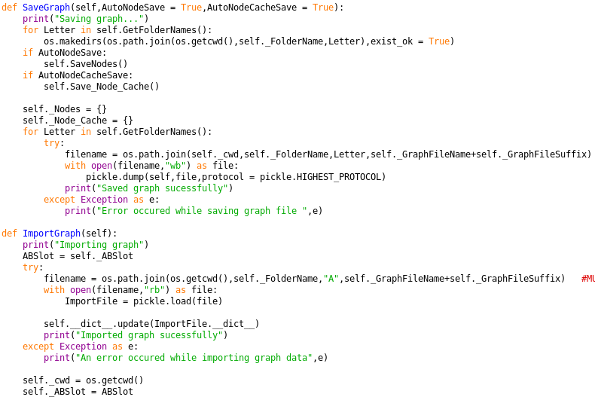
The import graph method is used to load a configured graph from a saved file. The ABSlot attribute is backed up to a local variable. The file is opened and the imported file is saved into ImportFile. The attributes of the current graph are overwritten with those of the imported graph, loading attributes such as xSize or BlockSize and any exception will be caught. The cwd and ABSlot are returned to their correct values ( to ensure os compatibility and correct file loading respectively).

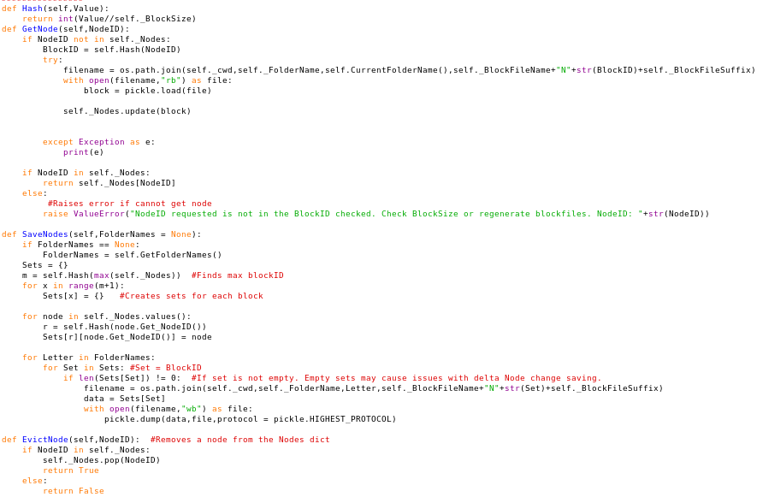
The hash function takes a value and returns the integer division result by the block size, this is used to find the correct file ID in which the node will be stored.

The GetNode method takes a nodeID being searched for , if the node is not in the loaded set of nodes the blockID is calculated using the above mentioned hash function and that file is opened. That file is then added to the Nodes dictionary , any exceptions are caught by the try except statement. The NodeID is then searched for in the dictionary, if it is found the node is returned, otherwise an exception is raised.

The SaveNodes method is used to save all the nodes of the graph. It creates a number of sets from 0 → hash of the largest node and places each node using its hash value into a set. The program then saves all the nodes either for all the folders or for the subset passed as a parameter of FolderNames.

Evict Node removes the node with that NodeID from memory , returning True if the node was in memory and false if it was not. This can be used to reduce memory consumption if a node is known no longer to be of use.

Misc
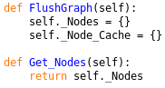
FlushGraph empties all the nodes and node_cache in memory, this can be used to reduce memory consumption between searches on a single graph or can be used to test the performance of a search repeatedly without the caching effects of having the node objects in memory, i.e. if one wanted to perform tests on the capabilities of the storage device for searching new , unloaded graphs.

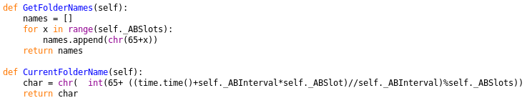
GetFolderNames returns a list of all subfolder names which will be used.
CurrentFolderName calculates the current subfolder name using the previously explained equation, returning the relevant string.

Node
The node class is a data structure used to store a single node on a graph, it’s location, the cost of movement through that node and it’s neighbours.
It contains the information about each of it’s neighbours in a list rather than for the entire graph in a set. Although storing the values in a set may seem to be a better choice as the edges of a graph are not normally stored in the nodes themselves the use of lists in the nodes as storage of the neighbours is benifitial. Firstly the search algorithm requires that each neighbour of the current node be iterated through , if a list is used this is simple and fast while the use of a set would require the the program to search through the entire dictionary for any keys relevant to the current node, taking a much longer time. Furthermore in order to search through the entire set the set must be loaded into memory, taking time and space , even for parts of the set which will not be used. In comparison the use of storing the neighbours in a list in the node causes only thouse values to be loaded which are needed, reducing memory usage.

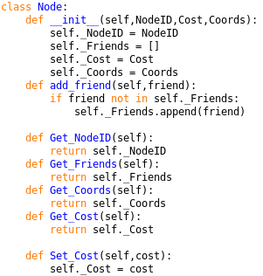
When instanciated the node requires 3 arguments, Integer NodeID, integer or float cost and AATC_Coordinate.Coordinate Coords.
The add_friend method takes a single argument of type int, a NodeID of a neighbouring node and adds it to the list of Friends/Neighbours.
The Get_NodeID method returns the NodeID of that node.
The Get_Friends method returns the list of neighbours for that node.
The Get_Coords method returns the coordinate object for that node.
The Get_Cost method returns the cost of that node.
The Set_Cost method takes a single float or integer arguments and sets the cost to that value.

The A* algorithms and related functions
For explanation on the functioning of the A* algorithm and the base pseudocode:https://en.wikipedia.org/wiki/A*_search_algorithm#Pseudocode

The EstimateDistance method is the heuristic of this A* algorithm. It takes 5 arguments, a Node Node, a Node Target , float xSize, float ySize, float zSize. The coordinates of the Node and Target are obtained and the heuristic calculated. The heuristic finds the difference in each dimension and divides that by the step size in that dimension, obtaining a number of steps in each dimension. The absolute values of these values are summed and returned, giving the heuristic estimate.

There are two similar A* algorithms which can be used to perform searches on a graph, Astar2 and AstarPQ. The difference is only the way the f value is stored. The Astar2 variant uses a conventional list to store the f values while the PQ variant uses a priority queue. In general as the size of f increases the relatively faster the PQ variant becomes due to having a time compexity for f searches of O(Log N) and insert time of O(Log N) compared to search time of O(N) and insert time of O(1) for Astar2. The point at which the PQ variant is faster varies, the use of the C variant of the PQ lowers this threshold noticably.

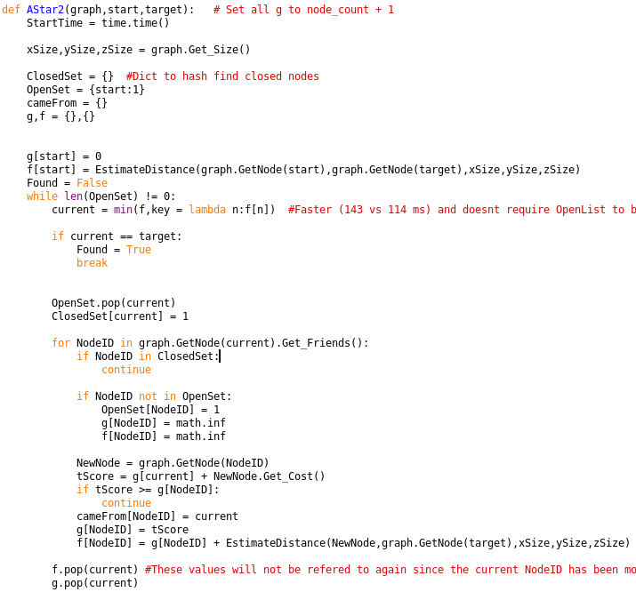

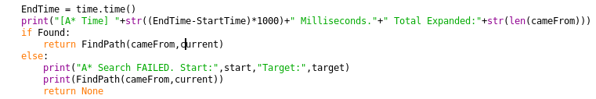
The Astar2 function requires 3 arguments, a DynoGraph graph, an integer start and an integer end.
The start time is recorded and the x,y,z sizes of the graph are obtained. The ClosedSet,OpenSet,cameFrom,g and f dictionaries are initialised with OpenSet containing the start NodeID. Note: Dictionaries are used instead of sets due to being simpler, the memory usage and speed are almost identical. The g and f values are setup for the start node using the EstimateDistance function for f. The Found variable is set to False and the search is started.

The main loop will continue until the openset is empty or the target is found. First the current NodeID is obtained from the minimum of the f dictionary where the value of the dictionary pair is used to find the minimum.

The current value is then checked against the target value, if they match found is set to true and the loop is broken. Should this not be the case the current node is removed from the openset and is added to the closed set.

For each of the Nodes neighbours :
1. The new node is check if it is the closed set, if it is it is ignored.
2. If it is not in the open set is it added to the openset and the g and f values are initialised to infinity.
3. The NewNode is loaded by the graph using the nodeID.
4. The cost to get to that node is set to the current nodes g value and added to the new nodes cost.
5. Should the new value not be an improvement over the nodes current g value then the loop continues without executing the rest of the loop.
6. The cameFrom for that node is updated to the current value.
7. The g value of the new node is set to the t value created.
8. The f value of the nodes is set to the g value of the node plus the estimated distance of the node to the target.

Once this is complete the f and g value of the current node are removed as they will not be used again (as the node is now in the closed set) in order to reduce memory usage.

Once the search is completed the time taken is measured and displayed along with the total number of searched nodes. If the search was sucessful and the target node was found the program returns the result of the FindPath function using the cameFrom and current variables, if not None is returned and a failure message displayed along with the last path.

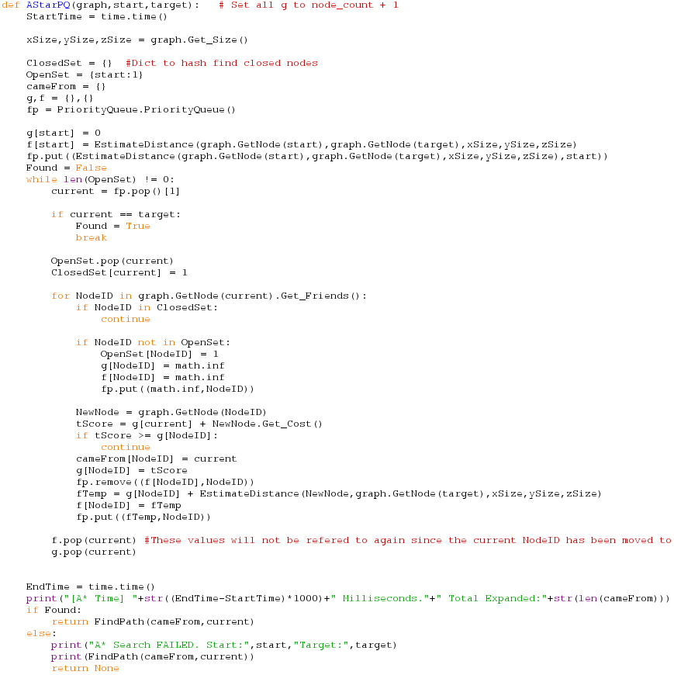
The AstarPQ variant is very similar and follows the same base algorithm, therefore only the differences will be described.
During the setup time a priority queue is setup in the variable fp to which the tuple of (distance,nodeID) of the start node is added.
When a new current node is to be selected one pops the first item off the fp queue and takes the NodeID (second value in list). This takes O(1) time.
When expanding the neighbours of the node and the neighbour is not in the open set the priority queue is added to with the tuple (infinity,NodeID) to initialise the value. Later when the f score it to be setup the tuple for that nodeID is removed from the priority queue as that will now be invalid and the new f value stored in a tempoary variable. This value is then used to add to the f dictionary as well as the priority queue. This takes O(Log N) time.

The time taken for each variant varies depending on the number of nodes expanded e.g. N. For each node expanded Astar2 takes about N+k steps while AstarPQ takes KlogN steps, where k and K are not the same and may vary depending on other components. This means that PQ will eventually be faster than Astar2 , however the threshold value may vary greatly and the IO bound nature of an unloaded graph will cause the times for both to be approximatly equal for most N.

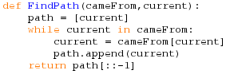
The find path function finds the path taken from the current node to the start node using the dictionary cameFrom and value current. The method takes the current item and puts into into the path list. Then it takes the value current came from, sets this to current and adds to list, repeating until current is no longer in the list (the start node is not in the list). Then the list is reveresed (so it is start to end) and returned.

Miscellanious items
Note: These items are simply for testing purposes/benchmarking. They are not used unless they are explicitly called. Their purpose is to allow users to test various settings for block size etc and the impact on performance and memory usage as well as debugging. Therefore the programs may use direct access to class attributes to modify or obtain their length.

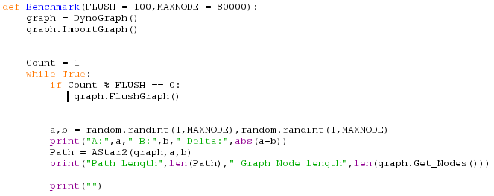
Benchmark provides a way to measure the ability for the IO system and general ability of the system to cope with many searches. It creates a graph and endlessly loops through searches for random nodes and displays details such as time and length for each search. Every FLUSH searches the graph nodes are flushed to return to a blank state.

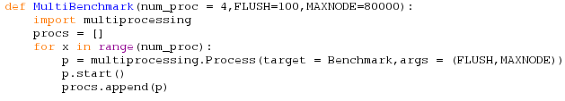
MultiBenchmark extends Benchmark with a simple way of testing multiple copies of the benchmark with multiprocessing. The num_proc controls the number of processes created. This is a good example of how caching of the graph by the OS and DynoGraph can lead to large performance improvements. WARNING: This will load num_proc copies of the Astar search, this may take up large amounts of memory if Flush or MaxNode is too high causing swapping and a system freeze.

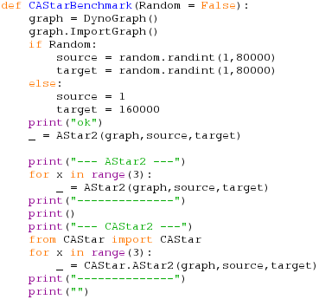
The CAStar benchmark is similar to benchmark however the program takes an optional random variable only which controls if the points chosen should be random. A graph is setup and an initial load is performed (search after print(“ok”)). Then for both Astar2 and CAStar2 3 sets of searches are performed on the same path , allowing the user to compare the performance.
Note: This requires the CAStar package which will not be included by default. This package is a compiled version of AATC_Astar using cython.

